Tessellations
Here is part of a tessellation:

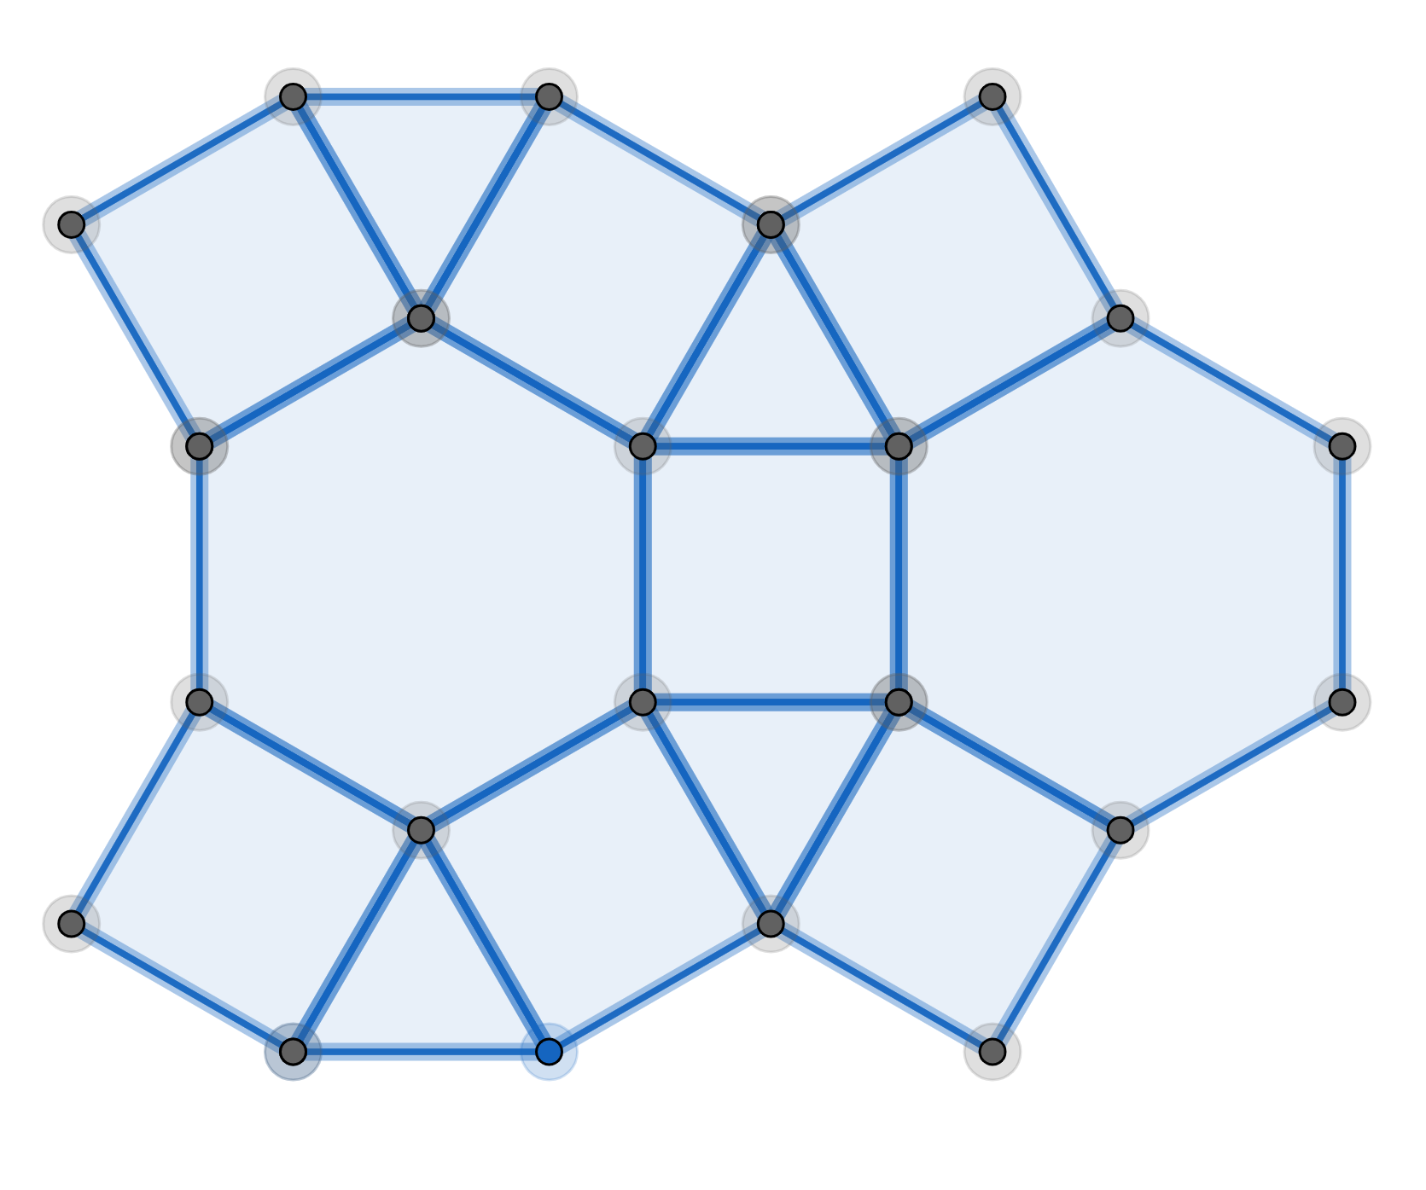

It is a tiling of the plane, with no gaps. You have to imagine the tiling extends in all directions.
If you walk (clockwise) around any vertex you will pass through a triangle then a square then a hexagon and then a square. We call this thetessellation.
The angles at a vertex must add-up to 360°
Here
In case you had forgotten, for regular polygons:
Number of sides | 3 | 4 | 5 | 6
Internal angle | 60° | 90° | 108° | 120°

The regular tessellations:
Here is thetessellation:

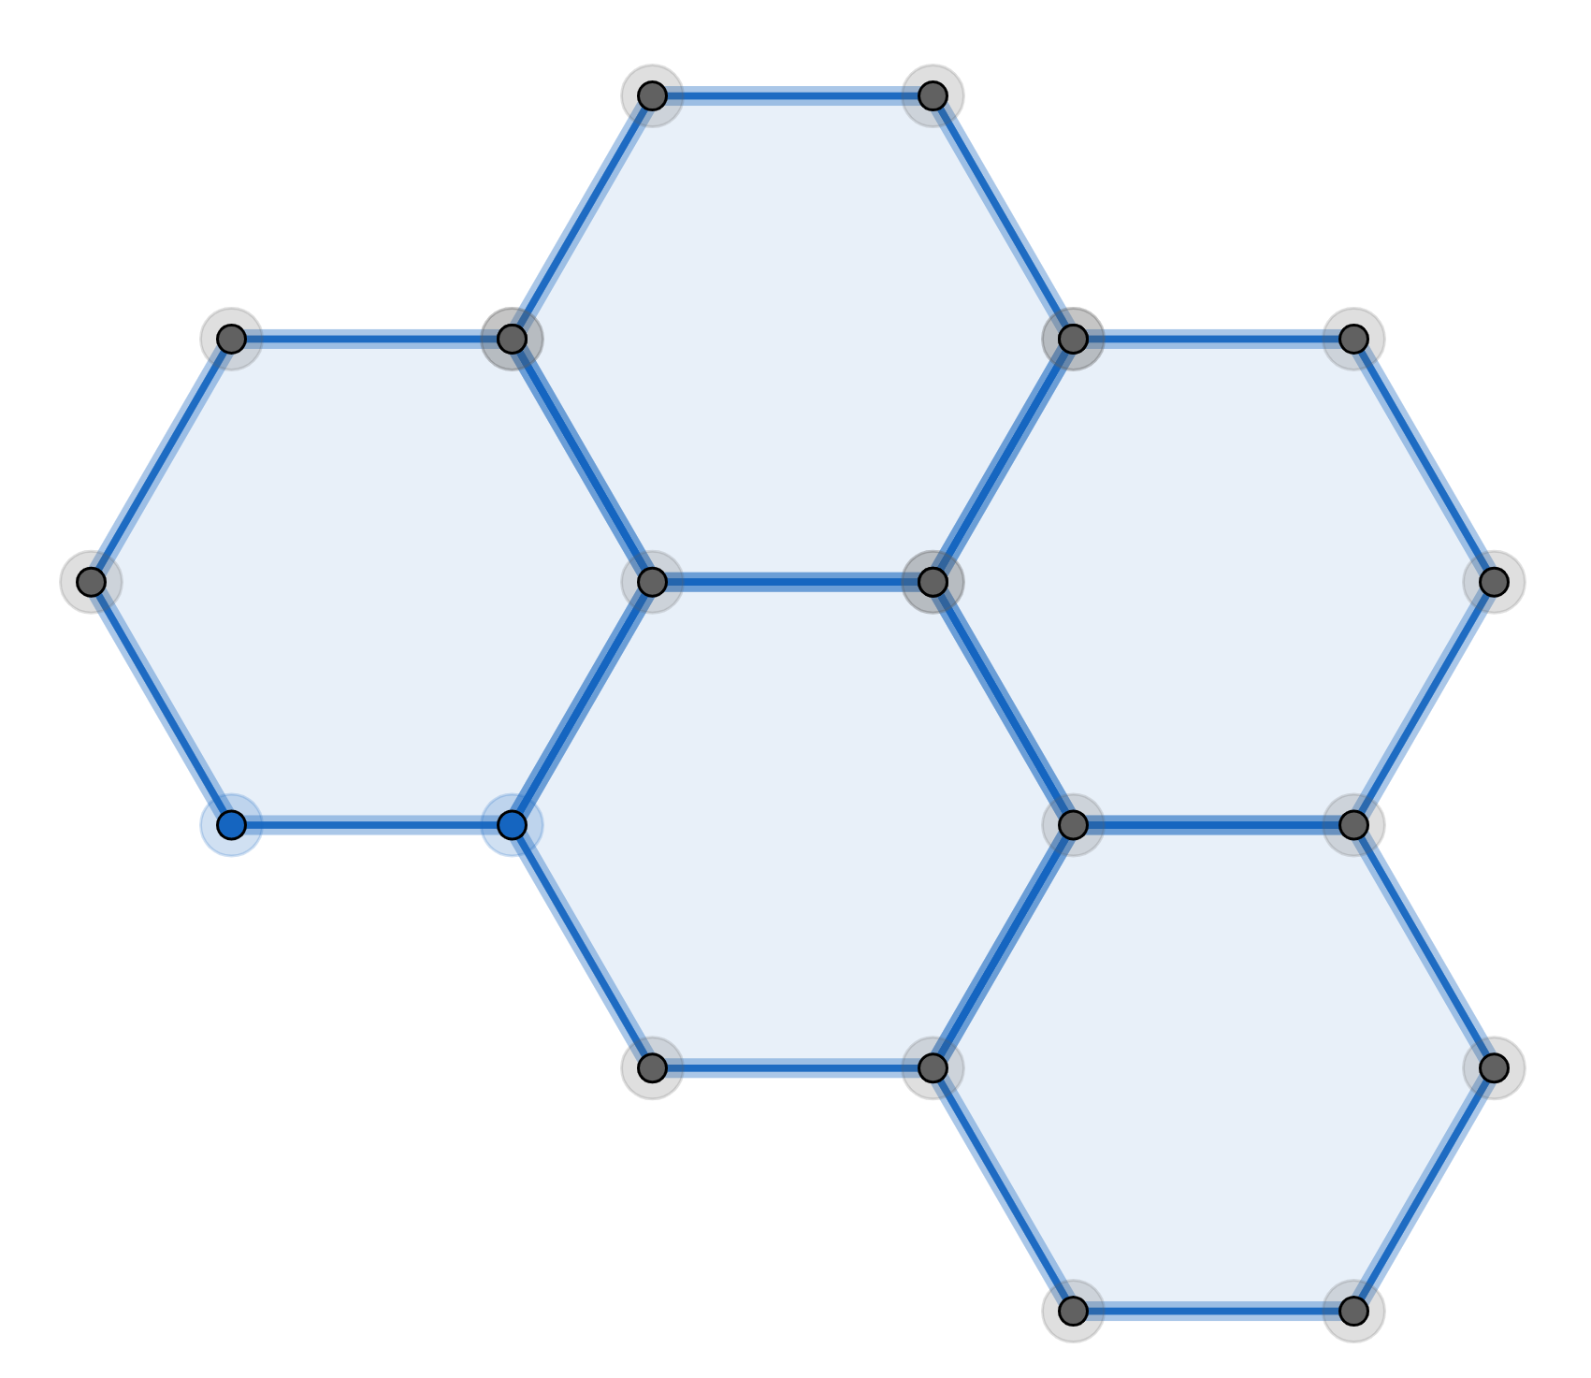

This is a regular tessellation because:
All the faces are identical.
All the faces are regular polygons.
All the vertices are surrounded by the same number of faces.
Theorem
There are only 3 regular tessellations

See Exercise 1

The semi-regular tessellations:
Look at the abovetessellation:
This is a semi-regular tessellation because:
All the triangles are identical.
All the squares are identical.
All the hexagons are identical.
All the faces are regular polygons.
All the vertices are surrounded by the same set of faces in the same order
Theorem
There are only 8 semi-regular tessellations

There are no semi-regular tessellations involving pentagons. Why not?
Remember, the angles at a vertex must add up to 360°

see Exercise 2

EXERCISE 1
Find the other 2 regular tessellations.

EXERCISE 2
Find the other 7 semi-regular tessellations. This is not easy!

SOLUTIONS 1
Hint: The angles at a vertex must add-up to 360°
This gives us the following regular tessellations:
and

SOLUTIONS 2
Hint: The angles at a vertex must add-up to 360°
This gives us the following semi-regular tessellations:
and

